ORIGINAL Project Title: The Use of Joystick Sensor
EDITED Project Title: Joystick Sensor
Link: https://wiki.microduino.cc/index.php/The_Use_of_Joystick_Sensor

ORIGINAL:
Microduino-Joystick sensor is equipped with a two-way analog output interface. Its output values correspond to offsets on both the X-axis and Y-axis. It is small and beautiful.
EDIT:
The Microduino Joystick sensor is two analog output devices in one. There are resistors on the X-axis and Y-axis that each output an analog value corresponding to the position of the joystick on that axis.
This sensor is great for controlling projects, especially ones that move.

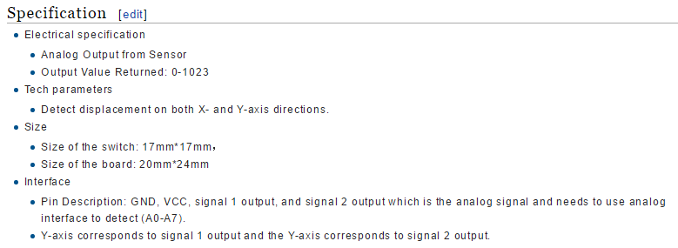

ORIGINAL:
- Electrical specification
  - Analog Output from Sensor
  - Output Value Returned: 0-1023
- Tech parameters
  - Detect displacement on both X- and Y-axis directions.
- Size
  - Size of the switch: 17mm*17mm，
  - Size of the board: 20mm*24mm
- Interface
  - Pin Description: GND, VCC, signal 1 output, and signal 2 output which is the analog signal and needs to use analog interface to detect (A0-A7).
  - Y-axis corresponds to signal 1 output and the Y-axis corresponds to signal 2 output.

EDIT:
- Electrical Specifications
  - Analog Output Device
  - Analog Output: 0-1023 (with Microduino Core modules)
- Technical Specifications
  - Analog Output Corresponding to X and Y-axis displacement
- Dimensions
  - Switch: 17mm x 17mm
  - Board: 20mm x 24mm
- Connection Interface
  - Pins: Signal 1 (X-Axis), Signal 2 (Y-Axis), VCC (power) and GND (ground)
  - Must be connected to analog capable ports (A0-A7)

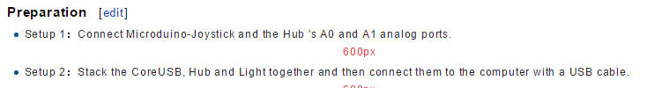

ORIGINAL:
- Setup 2：Stack the CoreUSB, Hub and Light together and then connect them to the computer with a USB cable.
EDIT:
- Setup2: Stack the CoreUSB and Hub together and then connect them to the computer with a USB capable.
- NEED TO ADD IMAGES OF CONNECTING COMPONENTS

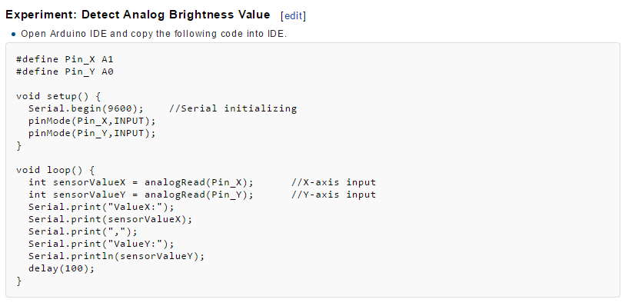

ORIGINAL:
Experiment: Detect Analog Brightness Value

EDIT:
Experiment: Read Analog Joystick Values

